1. Create folder for your app example “my-app”
2. Create packagejson file using at the command prompt “npm init”
   1. Change index.js to server.js
3. Install express concurrently “npm I express concurrently”
4. Install nodemon “npm i nodemon - -save-dev”
5. In packjson under scripts add your start file which will be “sever.js”
6. In packjson under scripts add a server script which will be ”server”: “nodemon server.js”

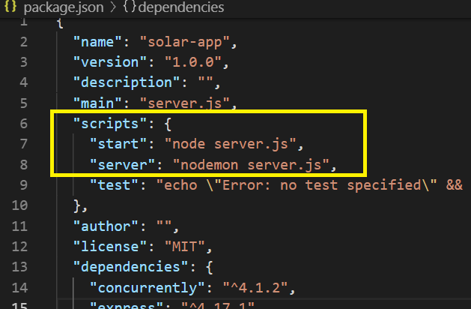

1. Create the server.js file
   1. const express = require('express');
   2. const cors = require('cors');
   3. const app = express();
   4. const mysql = require('mysql');
   5. const SELECT_ALL_Location_QUERY = 'SELECT * FROM location';
   6. const connection = mysql.createConnection({
   7. host:'localhost',
   8. user:'root',
   9. password:'dave',
   10. database:'Solar'
   11. });
   12. connection.connect(err => {
   13. if(err){
   14. return err;
   15. }
   16. });
   17. console.log(connection);
   18. app.get('/api/Students', (req,res) => {
   19. const Students = [
   20. { id: '1', firstname:'john', lastname:'crakers'},
   21. { id: '2', firstname:'willy', lastname:'smith'},
   22. { id: '3', firstname:'bill', lastname:'smith'}
   23. ];
   24. res.json(Students)
   25. });
   26. app.use(cors());
   27. app.get('/', (req,res) => {
   28. res.send('go to / Weather')
   29. });
   30. app.get('/weather/search', (req,res) => {
   31. const {cityid} = req.query;
   32. const SELECT_ALL_Weather_QUERY = 'SELECT * FROM weather WHERE Location_id = '+ cityid;
   33. connection.query(SELECT_ALL_Weather_QUERY,(err, results) =>{
   34. if(err) {
   35. return res.send(err)
   36. }
   37. else {
   38. return res.json({
   39. data: results
   40. })
   41. }
   42. });
   43. });
   44. app.get('/location', (req,res) => {
   45. connection.query(SELECT_ALL_Location_QUERY,(err, results) =>{
   46. if(err) {
   47. return res.send(err)
   48. }
   49. else {
   50. return res.json({
   51. data: results
   52. })
   53. }
   54. });
   55. });
   56. const port = 4000;
   57. app.listen(port, () => console.log('Server started on port ' + port));
2. Now to setup the client – “npm init react-app client”
3. Go to the client directory
4. Edit packjson and add a proxy to this file so the backend can talk to the front end
   1. Add “proxy”:”http://localhost:4000”
   2. 